HIP DYSPLASIA

Hip dysplasia means abnormal development of the hip joint. It is a multifactorial condition that usually is triggered by genetic predisposition followed by a predictable chain of events resulting in joint laxity and subsequent degenerative changes. Progression of hip dysplasia is influenced by size, growth rate, and body condition. Degenerative changes include abnormal bone production, thickened femoral neck, joint capsule fibrosis, and subluxation or luxation of the femoral head creating discomfort and pain. To treat this condition, Dr. Nunley performs a Femoral Head Ostectomy. This procedure is ideally restricted to patients weighing 50 pounds. The total hip replacement (THR) is a better option in larger pets or performance animals.

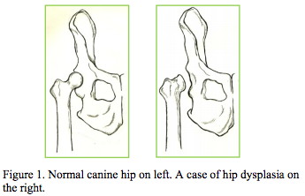

DIAGNOSIS

Lameness may appear mild, moderate, or severe and may become more pronounced after exercise or a long walk. The patient may be slow when rising and may take some time to warm out of joint stiffness, but is still weightbearingon the affected limb. A definitive diagnosis and evaluation of each patient requires palpation and manipulation of the hip. Radiographs (x-rays) of the hip joints are required for preoperative evaluation and surgical planning.

SURGICAL REPAIR‐ FHO

The FHO procedure eliminates the “bone-to-bone” contact between the head of the femur and the degenerated hip socket that causes pain. Stress radiographs (or distraction radiographs) are taken prior to surgery to confirm and assess abnormal hip position and degenerative changes. During surgery, Dr. Nunley will remove the “ball” of the femur that normally fits in the socket of the pelvic bone. A false joint is created that is supported by the large muscle mass around the hip. Post surgery, most patients experience a 70-80% return to normal function and a painfree active life.

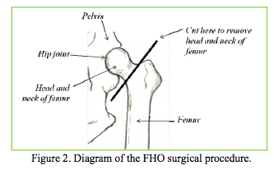

COMPLICATIONS

Though the FHO is a simple surgery, it requires a complex rehabilitation program. Without aggressive rehabilitation, patients are at risk for rotational instability, dorsal femoral displacement, bone-bone contact, residual pain in hip extension, and possible limb disuse. Dogs over 50 pounds tend not to do well with this surgery. Well muscled and active dogs will also usually have a quicker and more
complete recovery than overweight, inactive patients.

WHAT WE DO

TVSS is a surgical practice designed to provide excellent surgical care for your pet without disturbing the client referring veterinarian relationship. Our team performs a variety of orthopedic and soft-tissue procedures at your pet’s hospital, which allows for the convenience and comfort of being in a familiar surrounding. We will offer you outstanding customer service and compassionate care.Your veterinarian will perform most of the follow-up care, but we are available if concerns arise.

