CRANIAL CRUCIATE LIGAMENT RUPTURE
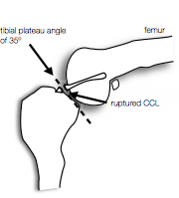
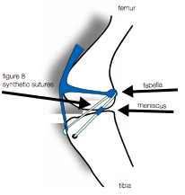
The most common injury we see in our canine patients is a rupture of the cranial cruciate ligament (CCL). A rupture of this ligament can cause pain and lameness, injury to other structures of the knee, such as the medial meniscus, and will lead to arthritis in the joint. The injury is very common in all sizes and types of dogs. The CCL is analogous to the ACL in people. There are two surgical procedures that Dr. Nunley performs in order to treat the CCL injury. The Tibial Plateau Leveling Osteotomy (TPLO) is usually reserved for larger (over 45 pounds), more active and younger dogs. The Extra Capsular Repair (ECR) has the most consistent results in smaller and less active dogs. Long-term prognosis for pets after surgery is good, with clinical reports of improvement in 85-95% of the cases.

DIAGNOSIS
Lameness may be very obvious right away or appear gradually. The discomfort exhibited varies from mild, intermittent lameness to continuous, non-weight-bearing lameness. A definitive diagnosis and evaluation of each patient requires palpation and manipulation of the knee. Radiographs (x-rays) and palpation under sedation are required for preoperative evaluation and surgical planning.

SURGICAL REPAIR – TPLO

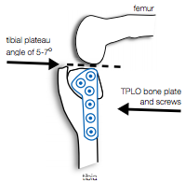
The TPLO procedure stabilizes the knee biomechanically by leveling the tibial plateau. Radiographs of the knee will be taken prior to surgery to measure your pet’s tibial plateau angle. During surgery, the joint is examined in order to remove the remnants of the ligament as well as to inspect the other structures in the joint. If damage to the meniscus is found, the damaged portion is removed. After the joint is closed, a cut is made through the tibia using a bone saw.

The cut allows rotation of the tibial plateau to level the loadbearing surface of the tibia (usually between 5 and 7 degrees). After the rotation, a specialized bone plate is secured to the bone with screws. Leveling the tibial plateau eliminates cranial tibial thrust and stabilizes the joint.

SURGICAL REPAIR – ECR

Just like the TPLO, this surgery starts with a joint exploration, which allows for removal of the cruciate remnants as well as inspection of the rest of the knee joint. Once the joint is closed, heavy duty nylon (usually two strands) is placed in the tissue between the femur and the fabella. The nylon is then passed under the patella ligament and back through a small hole made in the top of the tibia. Each strand of nylon is secured to itself with a stainless steel crimp. This procedure eliminates the instability in the knee joint. Over the first 8-12 weeks after surgery, your pet will be laying down scar tissue around the joint, essentially taking over for the nylon, which can weaken or loosen over time.

COMPLICATIONS
Complications are rare and will vary depending on which procedure is performed. Infection, delayed wound healing, implant failure, fracture, patella luxation and failure to return to function are the most common. Limb deformities can occasionally arise following the TPLO surgery. A small number of pets (10%) can injure their meniscus after surgery, which may require a second surgery. About 40-60% of dogs will rupture the opposite CCL within two years.

